Tutorial 8

I am using sqlite3 with python to set up my tables

Screen shot of both tables

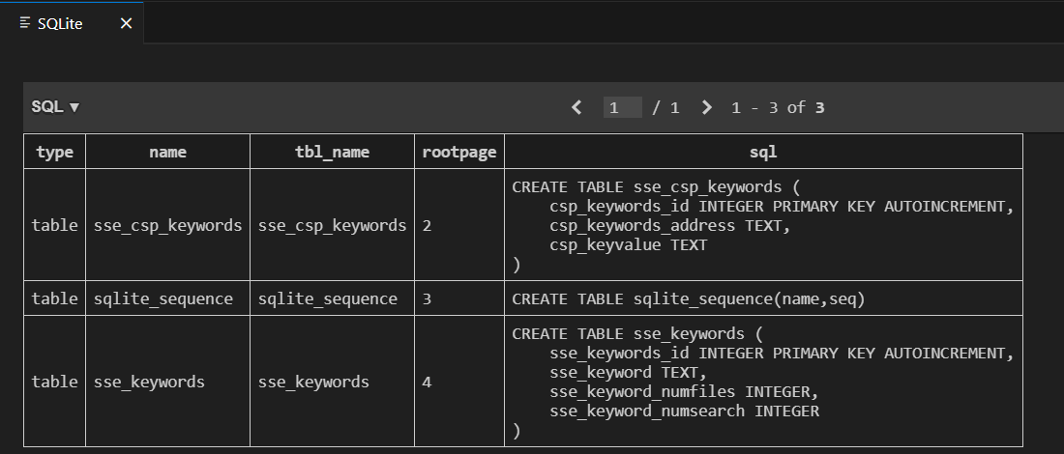

Set up script

Rest of the work by the script

import sqlite3

import os

import hashlib

import time

from cryptography.hazmat.primitives.ciphers import Cipher, algorithms, modes

from cryptography.hazmat.backends import default_backend

import secrets

from cryptography.hazmat.primitives import padding

# Connect to the SQLite database

conn = sqlite3.connect('./sse_schema.db')

cursor = conn.cursor()

# Create necessary tables if they don't exist

cursor.execute('''CREATE TABLE IF NOT EXISTS sse_csp_keywords (

    csp_keywords_id INTEGER PRIMARY KEY AUTOINCREMENT,

    csp_keywords_address TEXT,

    csp_keyvalue TEXT

)''')

cursor.execute('''CREATE TABLE IF NOT EXISTS sse_keywords (

    sse_keywords_id INTEGER PRIMARY KEY AUTOINCREMENT,

    sse_keyword TEXT,

    sse_keyword_numfiles INTEGER,

    sse_keyword_numsearch INTEGER

)''')

conn.commit()

# Define folder path for text files

folder_path = './textfiles/'

# Define AES key (use your actual KSKE here)

KSKE_hex = '8da5ed8fdd57592c388e638fb56b82fecf3e563c37897a97893b33b4308f9c91'

KSKE = bytes.fromhex(KSKE_hex)

# AES encryption function with padding

def aes_encrypt(data, key):

    iv = secrets.token_bytes(16)

    cipher = Cipher(algorithms.AES(key), modes.CFB(iv), backend=default_backend())

    encryptor = cipher.encryptor()

    # Pad data to ensure it's a multiple of 16 bytes (AES block size)

    padder = padding.PKCS7(algorithms.AES.block_size).padder()

    padded_data = padder.update(data) + padder.finalize()

    return iv + encryptor.update(padded_data) + encryptor.finalize()

# SHA-256 hash function for keywords

def hash_word(word):

    return hashlib.sha256(word.encode()).hexdigest()

# Keyword key computation

def keyword_key(keyword, numsearch):

    combined = f"{keyword}{numsearch}".encode()

    return hashlib.sha256(combined).hexdigest()

# Compute CSP keywords address

def csp_keyword_address(Kw, numfiles):

    combined = f"{Kw}{numfiles}".encode()

    return hashlib.sha256(combined).hexdigest()

# Insert or update keyword in the database

def insert_or_update_keyword(cursor, keyword_hash, numfiles, numsearch):

    # Check if the keyword already exists

    cursor.execute('''

    SELECT sse_keyword_numfiles, sse_keyword_numsearch FROM sse_keywords WHERE sse_keyword = ?

    ''', (keyword_hash,))

    result = cursor.fetchone()

    if result:

        # Keyword exists, update numfiles and numsearch

        existing_numfiles, existing_numsearch = result

        new_numfiles = existing_numfiles + numfiles  # Increment numfiles

        # new_numsearch = existing_numsearch + 1       # Increment numsearch

        cursor.execute('''

        UPDATE sse_keywords SET sse_keyword_numfiles = ?

        WHERE sse_keyword = ?

        ''', (new_numfiles, keyword_hash))

    else:

        # Keyword doesn't exist, insert new record

        cursor.execute('''

        INSERT INTO sse_keywords (sse_keyword, sse_keyword_numfiles, sse_keyword_numsearch)

        VALUES (?, ?, ?)

        ''', (keyword_hash, numfiles, numsearch))

# Collect all CSP keywords data for later processing

def collect_csp_keywords_data(cursor):

    cursor.execute('''

    SELECT sse_keyword, sse_keyword_numfiles FROM sse_keywords

    ''')

    return cursor.fetchall()

total_size = sum(os.path.getsize(os.path.join(folder_path, f)) for f in os.listdir(folder_path) if f.endswith('.txt'))

# Start execution timer

start_time = time.time()

# First Pass: Process each file to update the sse_keywords table

for filename in os.listdir(folder_path):

    if filename.endswith('.txt'):

        file_path = os.path.join(folder_path, filename)

        # Read the original file to extract keywords

        with open(file_path, 'r') as file:

            words = file.read().split()

        numfiles = 1  # Each file contains these keywords at least once

        # Process each word to update the sse_keywords table

        for word in words:

            keyword_hash = hash_word(word)

            insert_or_update_keyword(cursor, keyword_hash, numfiles, 1)

# Second Pass: Encrypt and delete all files

for filename in os.listdir(folder_path):

    if filename.endswith('.txt'):

        file_path = os.path.join(folder_path, filename)

        # Read and encrypt the file

        with open(file_path, 'rb') as file:

            data = file.read()

            encrypted_data = aes_encrypt(data, KSKE)

        # Save encrypted file and delete the original

        with open(file_path + '.enc', 'wb') as encrypted_file:

            encrypted_file.write(encrypted_data)

        os.remove(file_path)  # Delete original .txt file

# Third Pass: Compute and insert CSP keywords based on the populated sse_keywords table

csp_keywords_data = []

for keyword, numfiles in collect_csp_keywords_data(cursor):

    kw = keyword_key(keyword, 1)

    # Print parameters before calculating CSP address

    # print(f"Calculating CSP address with keyword: '{kw}' and numfiles: {numfiles}")

    address = csp_keyword_address(kw, numfiles)

    encrypted_filename = aes_encrypt(f"{filename}{numfiles}".encode(), KSKE)

    # print(f"Encrypted with aes: {filename} + {numfiles}")

    csp_keywords_data.append((address, encrypted_filename))

# Insert collected CSP keywords data into the database

for address, encrypted_filename in csp_keywords_data:

    cursor.execute('''

    INSERT INTO sse_csp_keywords (csp_keywords_address, csp_keyvalue)

    VALUES (?, ?)

    ''', (address, encrypted_filename))

# Commit all changes

conn.commit()

# End execution timer

end_time = time.time()

execution_time = end_time - start_time

print(f"Total execution time: {execution_time:.2f} seconds")

print(f"Total combined size of test files: {total_size} bytes")

conn.close()

I generate 25 random text files as

import os

import random

# Folder path for the generated .txt files

folder_path = 'textfiles/'

# Ensure the folder exists

os.makedirs(folder_path, exist_ok=True)

# List of common English words

word_list = [

    "apple", "banana", "orange", "grape", "pineapple", "strawberry", "blueberry", "mango", "peach", "lemon",

    "cherry", "watermelon", "pear", "plum", "kiwi", "melon", "lime", "coconut", "apricot", "grapefruit",

    "berry", "papaya", "guava", "fig", "date", "pomegranate", "citrus", "nectarine", "raspberry", "blackberry"

]

# Function to generate random text content with one unique word per line

def generate_random_text():

    # Choose a random number of unique words for the file (between 5 and 30)

    num_words = random.randint(5, min(30, len(word_list)))  # Ensure it doesn't exceed the number of unique words

    chosen_words = random.sample(word_list, k=num_words)  # Choose unique words

    return '\n'.join(chosen_words)  # Join words with line breaks

# Generate 25 .txt files with varied sizes

for i in range(1, 26):

    file_content = generate_random_text()  # Generate unique words for each file

    file_path = os.path.join(folder_path, f'test_file_{i}.txt')

    with open(file_path, 'w') as f:

        f.write(file_content)

print("25 .txt files with random unique words per line have been created.")

It would be much better if 25 txt files are provided since I had to changed this code many times to get possible files.

Output of the script

aroraan@HP-Elitebook:/mnt/c/TAU/aliceAndBob/tutorial8 (main)$ python3 database.py

KSKE is : 8da5ed8fdd57592c388e638fb56b82fecf3e563c37897a97893b33b4308f9c91

Total execution time: 8.82 seconds

Total combined size of test files: 2909 bytes

Searching script

import hashlib

import time

import sqlite3

from cryptography.hazmat.primitives.ciphers import Cipher, algorithms, modes

from cryptography.hazmat.backends import default_backend

import re

# Define your AES key here (the KSKE from the previous script)

KSKE = '8da5ed8fdd57592c388e638fb56b82fecf3e563c37897a97893b33b4308f9c91'  # Replace this with your actual KSKE key from earlier

KSKE = bytes.fromhex(KSKE)

# AES decryption function

def aes_decrypt(data, key):

    iv = data[:16]

    cipher = Cipher(algorithms.AES(key), modes.CFB(iv), backend=default_backend())

    decryptor = cipher.decryptor()

    return decryptor.update(data[16:]) + decryptor.finalize()

# SHA-256 hash function for keywords

def hash_word(word):

    print(f"Hash of {word} is: ", hashlib.sha256(word.encode()).hexdigest())

    return hashlib.sha256(word.encode()).hexdigest()

# Keyword key computation

def keyword_key(keyword, numsearch):

    combined = f"{keyword}{numsearch}".encode()

    return hashlib.sha256(combined).hexdigest()

# Compute csp_keywords_address

def csp_keyword_address(Kw, numfiles):

    combined = f"{Kw}{numfiles}".encode()

    return hashlib.sha256(combined).hexdigest()

# Connect to the database

conn = sqlite3.connect('./sse_schema.db')

cursor = conn.cursor()

# Start search timer

start_time = time.time()

# 1. Ask Bob to enter a word to search for

search_word = input("Enter the word you want to search for: ")

# 2. Create SHA-256 hash of the word to generate the keyword value

keyword_hash = hash_word(search_word)

# 3. Retrieve numfiles and numsearch for the keyword from sse_keywords table

cursor.execute('''

SELECT sse_keyword_numfiles, sse_keyword_numsearch FROM sse_keywords WHERE sse_keyword = ?

''', (keyword_hash,))

result = cursor.fetchone()

if result:

    numfiles, numsearch = result

    # 4. Compute the keyword key Kw

    Kw = keyword_key(keyword_hash, numsearch)

    # print(Kw, numsearch)

    # 5. Compute csp_keywords_address

    csp_address = csp_keyword_address(Kw, numfiles)

    # print(csp_address, numfiles)

    # 6. Retrieve csp_keyvalue using csp_keywords_address

    cursor.execute('''

    SELECT csp_keyvalue FROM sse_csp_keywords WHERE csp_keywords_address = ?

    ''', (csp_address,))

    encrypted_filename_result = cursor.fetchall()

    if encrypted_filename_result:

        # If results are found, decrypt each associated file

        for (encrypted_filename,) in encrypted_filename_result:

            print(encrypted_filename.hex())

            # 7. Decrypt the filename and numfiles from csp_keyvalue

            decrypted_info = aes_decrypt(encrypted_filename, KSKE).decode()

            print("Checking: ", decrypted_info)

            decrypted_info = re.sub(r'\\.*$', '', repr(decrypted_info))

            match = re.match(r"(.+?)(\d+)$", decrypted_info)

            if match:

                filename = match.group(1).lstrip("'")   # Extracts 'test_file_1.txt'

                file_num = match.group(2)   # Extracts '1'

                print("Filename:", filename)

                print("File Number:", file_num)

                # 8. Decrypt the file content

                file_path = f'./textfiles/{filename}.enc'

                try:

                    with open(file_path, 'rb') as encrypted_file:

                        encrypted_data = encrypted_file.read()

                    decrypted_data = aes_decrypt(encrypted_data, KSKE).decode()

                    print(f"Decrypted content of {filename}:")

                    print(decrypted_data)

                except FileNotFoundError:

                    print(f"File {file_path} not found.")

            else:

                print("Format error in decrypted_info.")

    else:

        print("No CSP key values found for the specified keyword.")

else:

    print("No files found containing the specified word.")

# Measure end time and calculate search time

end_time = time.time()

search_time = end_time - start_time

print(f"Time taken to search for the keyword: {search_time:.2f} seconds")

# Close database connection

conn.close()

output

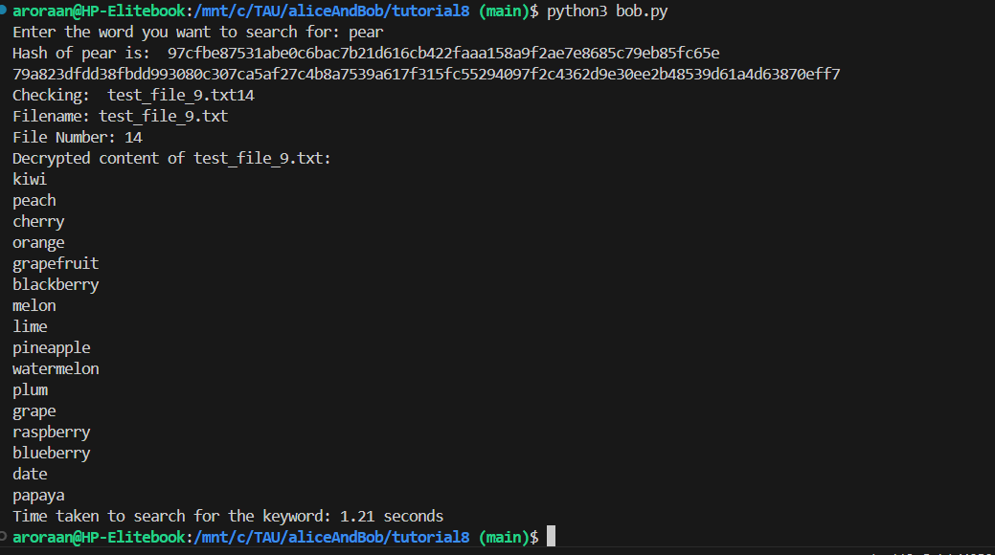

If word not found

This assignment would be way easier if txt files were given and csp_keyword updating and when to update numfiles and numsearch was given in more detail. Currently the tutorial takes focus away from actual working of database due to these other issues.